**Agile process:**

It is an **iterative** (same kind of process repeating again and again like as loop) **incremental** (implement the features at beginning and then adding new modules into that is called incremental) approach.

**Agile principle:**

* Customer no need to wait for long time
* We develop, test and release piece of software to the customer with few numbers of features
* We can accept / accommodate requirements changes from customer side in the middle time of developing

There will be good communication between customer, business analyst, developer and tester

**Advantage:**

* Requirement changes are allowed in any stage of development
* Releases will be very faster
* Customer no need to wait for the log time
* It is very easy model to adopt

**Disadvantage:**

* Less focus on design and developments since we deliver software very fast

**Scrum:**

Scrum is a framework through we build software product by following agile principles. Agile is a process where scrum is framework follow the agile process

**Scrum team**

* Product owner:
  + Define the features of product in the form of user story (Epic)
  + Prioritize features according to market value
  + Adjust feature and priority every iteration
  + Accept or reject work results
* Scrum master: It is a specific role having agile process skill set.
  + The main role facilitating and driving the agile process (it is a role or position in software industry).
* Dev team
* QA team

**Scrum Terminology:**

**User story:** A features or module of software

**Epic:** Collection of user stories

**Product backlog:** Contains list of all User stories & prepared by product owner

**Sprint/Iteration:** Period of time to complete the user stories, decided by the product owner and team. Normally 2-4 weeks of times

**Sprint planning meeting:** meeting conduct with the team to define what can be delivered in the sprint and duration (1 Day meeting)

**Sprint backlog:** List of committed stories by dev/QA for specific sprint

**Scrum meeting:** meeting conducted by the scrum master everyday 15 mins call as scrum call/standup meeting

**Sprint retrospective meeting:** conducts meeting after completion of sprint. The entire team, including both scrum master and product owner should participate

**Story point:** Rough estimation of user stories, will be given by dev and QA in the form of Fibonacci series. Dev and QA want time to complete user story in the particular sprint

0 1 2 3 5 8………

1 story point = 1 hour/1 day

Login->dev need 5 story point & QA need 3 story point = 8 hour / 1 day

**Burndown chart:** shows how much work remining in the sprint. Maintain by the scrum master

**Scrum Process:**

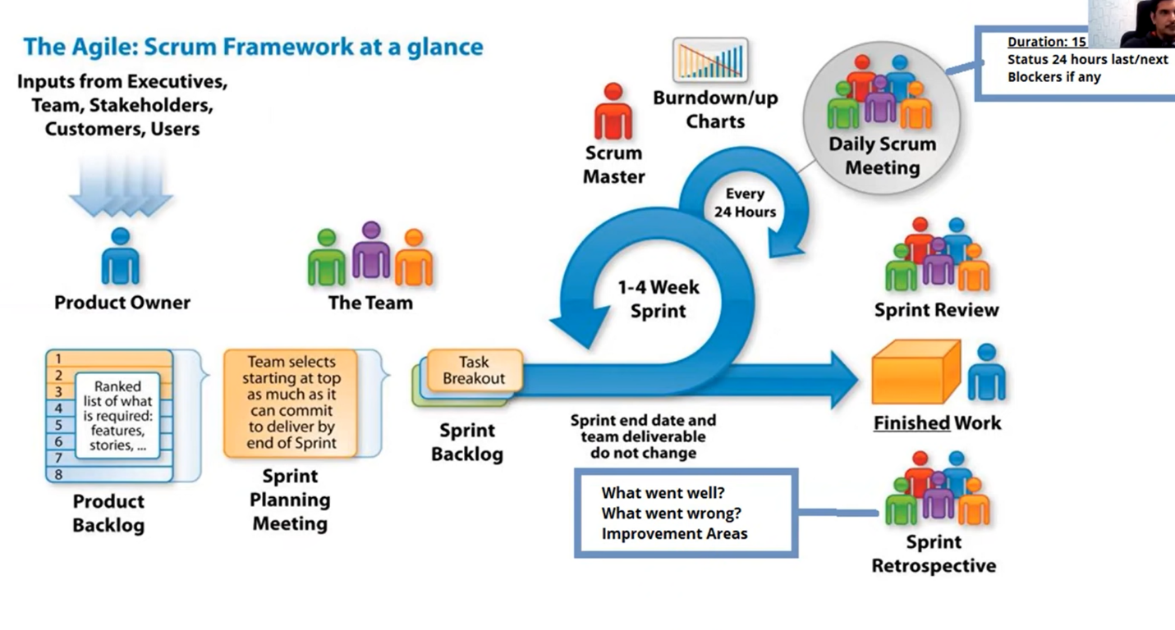

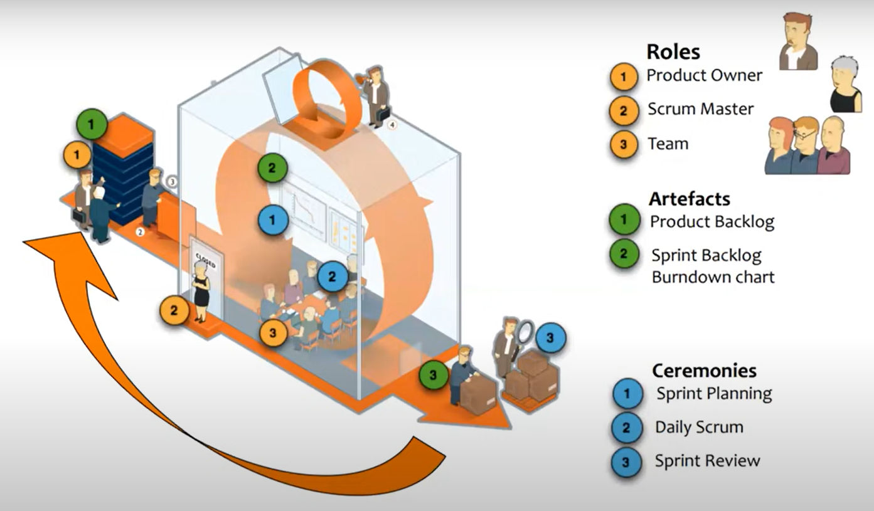

**Scrum Board:**

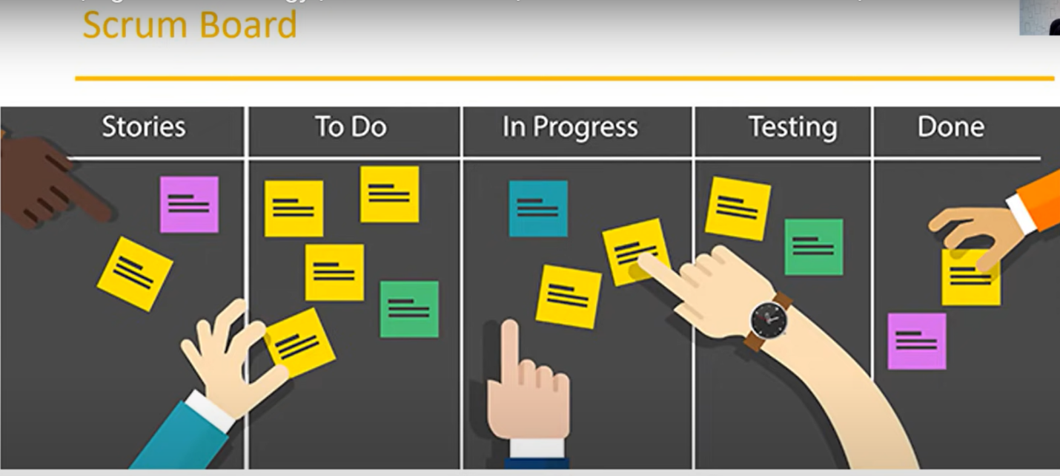

**Definition of Ready (DoR):**

* User story is clear
* User story is testable
* User story is feasible
* User story defined
* User story acceptance criteria defined
* User story dependencies
* User story sized by dev team
* Scrum team accepts user experience artefacts
* Performance criteria identified, where appropriate
* Team has a good idea what it will mean to demo the user story

**Definition of Done (DoD)**

* Code produced (all ‘to do’ items in code completed)
* Code commented, checked in and run against current version in source control
* Peer reviewed (or produced with pair programming) and meeting developments
* Unit tests written and passing
* Developed to system environment and passed system tests
* Passed UAT (User acceptance testing) and signed off as meeting requirements
* Any build/ deployment/configuration changes are implemented/documented/communicated
* Relevant documentation/ diagrams produced and / or updated
* Remaining hours for the task set to zero and task closed